Addendum # 2
Dated July 15, 2025

Revisions to Budget Management System (BMS) RFP

and

Request for Best and Final Offer (BAFO)

Budget Management System (BMS) RFP 2025-01
Solicitation No. 25001375

Due Date for BAFO: No later than 4:00 pm (HST) on Wednesday, July 30, 2025. BAFO response shall be submitted via HIePRO. No hard copy submissions will be accepted or required.

BAFO Instructions:

- The BAFO provides the Offerors with an opportunity to improve or otherwise amend any area or aspect of their original Proposal.

- If Offeror revises their original Proposal, Offeror must submit a letter summarizing all revisions to their initial proposal. The Offeror’s original Proposal, together with any amendments submitted in their BAFO, shall be considered as the Offeror’s BAFO.

- Offerors submitting a BAFO shall submit only the revised portions or sections of their original Proposal in track change mode. The portions of the original Proposal without any revisions do not have to be re-submitted.

- The Written Response to the discussion items (“WR”) shall be relied upon by the Department for clarification and assurances in the BAFO review and administration of the contract. Offerors shall submit their original WR, or a revised WR in track change mode, with their BAFO.

- All BAFO attachments shall be identified and include the naming convention “BAFO” (example: BAFO-001, BAFO-002, BAFO-003, etc.).

- If any Offeror fails to submit a BAFO by the Due Date, the Offeror’s original Proposal and the WR previously submitted shall be deemed to be their BAFO.

- Offerors may submit questions to this Addendum # 2 no later than 4:00 p.m. (HST) on Monday, July 21, 2025. Responses to the questions will be posted in HIePRO no later than 4:00 p.m. (HST) on Wednesday, July 23, 2025.

- The BAFO, along with the submittal letter and attachments, is due no later than 4:00 pm (HST) on Wednesday, July 30, 2025. BAFO responses shall be submitted via HIePRO. No hard copy submissions will be accepted or required.

Revisions:

Attachments A, C 1, C 2, and D referenced below are revised and are posted on the HIePRO site. The following is a summary of the revisions to the attachments.

Revision 1.

Attachment A Proposal Forms, Page 8, Table 2-02, Project Team Resource Hours. The “Instructions” language has been revised with strikethrough on deleted language and new language underscored.

Instructions: The Offeror is asked to provide the estimated number of resources that will be committed (both on-site and remotely) to the Project in terms of number of hours. These numbers The estimated number of hours should be based on the functionality the Department desires, included in the detailed Functional and Technical Specifications (Attachment B). It shall be clearly understood that the estimated number of Department staff and resource hours being provided does not commit or require the Department to provide the estimated number of staff or resource hours towards this Project. Furthermore, the estimated Offeror staff and resource hours being provided shall not be construed in any form as to limit the amount of Offeror staff and resource hours necessary for the Offeror to successfully implement this Project.

Revision 2.

Attachment A Proposal Forms, Page 15, Tab 4 – Project Approach and Implementation Methodology. The 2nd bullet point was deleted and replaced. Strikethrough on deleted language and new language underscored.

- With what frequency will the Offeror’s Project team staff be on-site at the Department during implementation? Will staff be on-site for full or partial weeks?

- Describe in detail the minimum number of on-site meetings to be provided, the purpose of the on-site visits, anticipated Offeror staff in attendance, and anticipated duration of the on-site meetings in days.

Revision 3.

Attachment A Proposal Forms, Page 24. Section A. Project Schedule. The 2nd bullet point was deleted and replaced. Strikethrough on deleted language and new language underscored.

- The Department would expect implementation to begin in July 2025.

- The Department anticipates that implementation activities would begin shortly after contract award anticipated in August 2025.

Revision 4.
Attachment A Proposal Forms, Page 25, Section D. Projected Go-Live Dates. The first paragraph has been revised with strikethrough on deleted language and new language underscored.

The Department anticipates that implementation activities would begin shortly after contract award anticipated in July August 2025. The Department is currently targeting March April 2026 as a go-live date for Rollout 1. The Department anticipates that Rollout 2-5 implementation activities will begin at a later date (See Attachment D – Outline of Budget Management System Dates for Operational Usage). The Department anticipates following best practices for the implementation timing of any additional modules.

Revision 5.

Attachment C1 Cost Worksheet. The reference to any type of optional services, items and cost in the “Vendor Hosted” and “Subscription” cost worksheets have been deleted. The cost submitted in Attachment C1 Cost Worksheet must include all costs being proposed to meet all requirements of the solution required by the Department. Strikethrough on deleted language.

Vendor Hosted: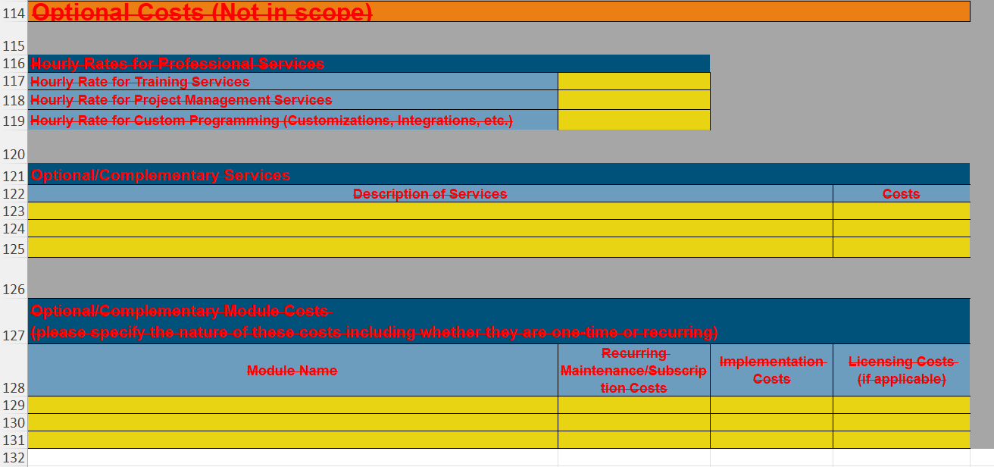

Subscription:
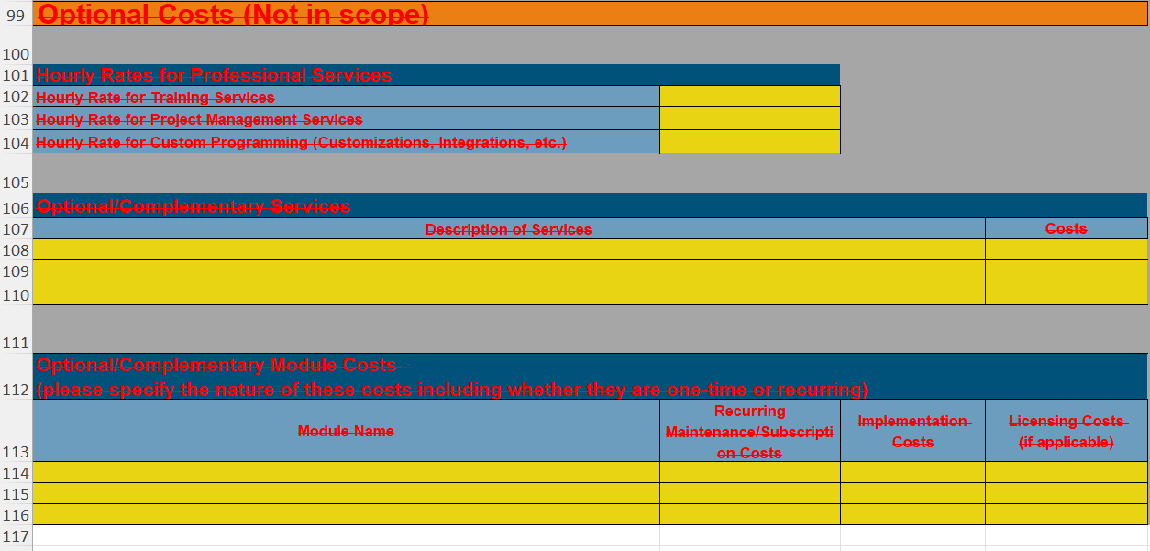

Revision 6

Attachment C2 Cost Narrative, Page 5, Section IV, Narrative Description of Price Proposal. Section IV has been revised with strikethrough on deleted language and new language underscored.

- NARRATIVE DESCRIPTION OF PRICE PROPOSAL

Proposers are encouraged to include a narrative description of the proposed costs, including, at a minimum the following:;

- Any optional services/offerings for professional services

Brief Statement:

- a. Any discounts that have been offered

Brief Statement:

- Any additional service offerings that may be out of scope, but may be available on an optional basis to serve to shift some of the implementation work effort from the Department to the vendor during implementation.

Statement:

- b. Any projected or anticipated cost savings or cost avoidance considerations related to the proposed software and services (savings in Department staff time, savings in ongoing hardware acquisition/maintenance costs, etc.)

Brief Statement:

- A description of any future upgrade costs, including upgrades to hardware, software, and related professional services costs (such as training, configuration, and other anticipated services costs related to upgrades in the future)

Statement:

f. c. A description of the estimated travel costs, including the number of trips, average duration of trips and number of staff included per trip, average cost per trip, and whether seasonality in pricing has been considered in the travel estimate.

Brief Statement:

- d. Other topics or statements related to the Price Proposal that the Proposer feels will help the Department better understand the pricing structure or key differentiators for the proposed products and services.

Brief Statement:

Revision 7.

Attachment D Budget Management System Operational Usage Timeline, Page 1, Rollout 1. 1st bullet point language has been revised with strikethrough on deleted language and new language underscored.

- Apr May ’26: Use of BMS program structure/narrative/measures update process for FB27-29 biennium budget preparation.

Revision 8.

Attachment D Budget Management System Operational Usage Timeline, Page 3, Rollout 1. 2nd full bullet point language has been revised with strikethrough on deleted language.

- Jul ’26: Use of all bond proceed use tracking and monitoring (taxable/tax exempt) related functionality, including, but not limited to, at the program appropriation/project ID/MOF and production of reports in various formats. (Optional at B&F’s discretion).

